**ULTRASONIC BLIND WALKING STICK**

**INTRODUCTION:**

Globally the number of people of all ages who are estimated to be blind is around 39 million. People of 50 years and older are 82% of all blind. The major cause of blindness is unaddressed refractive errors and cataract. The main problem of blind people is how to navigate their way to wherever they want to go. They can’t even walk on their own. They need assistance form others with good eyesight. Although the white cane (walking stick used by blind people) is used, it is difficult for a blind person to identify the obstacle. To overcome the problems faced by them, we propose an advanced blind stick that allows visually disabled people to navigate with ease.

**WHITE CANE (Blind walking stick):**

A white cane is normally a stick which allows its user to scan their surroundings for obstacles and places, but it also helps the others to identify the user ad blind or visually impaired and taking appropriate care. Even though it helps them to some extend most blind people find it difficult to move easily. Crossing the street is a real challenge for them on a daily basis. About 19.7% of visually disabled persons death is caused while crossing the road and other road accidents.

**ULTRASONIC BLIND WALKING STICK:**

This project is simply an advanced version of walking stick which uses advanced technology to navigate visually disabled peoples. The main objective of this project is to help blind people to walk independently with ease and to be warned whenever there is an object, people, obstacles or other similar odds in their walking path. This stick automatically detects the obstacle in front of the person and gives a response to the person by vibrating the stick and also with a warning sound. Through this project a visually disabled person can aware about the obstacles in front of him. And it also detects their paths bumpiness and detects if their path has any water stagnant.

This projects simply uses ultrasonic sensors to detect the obstacles ahead using ultrasonic waves. Firstly, the ultrasonic pulse is transmitted and received after hitting the obstacle in front. The received pulse is sent to a microcontroller and process the data and calculates the distance between the obstacle and the stick. If the obstacle is closer than a certain limit, the microcontroller sends the information to sound the buzzer. The closer the obstacle, the more will be the sound and vibrations produced. If the obstacle is not the close, the circuit does nothing.

**WORKING:**

This project uses an ultrasonic sensor which transmits a high frequency sound pulse and then calculates the time to receive the signals of the sound echo to reflect back. The sensor has 2 circuits, one acts as a transmitter and transmits the waves and the other one acts as a receiver which receives the echoed pulse. It uses an Analog sensor to detect the bumpiness and water stagnant on the path and the received signal is sent to the microcontroller. Arduino NANO is used as the microcontroller, which process the received signal and determines whether the object is closer or not and sends a signal to the buzzer and the vibrator motor which produces the sound and vibration in the stick. The sensor is calibrated according to the speed of the sound in air. Using the time difference between the transmission pulse and the received sound pulse, the distance between the object and the person can be determined. When the received pulse is higher which indicates the object is closer and when the received pulse is low, the object is far. Using this concept, the microcontroller sends signal to the buzzer and vibrator motor whose frequency of beep changes according to the distance of obstacle. Which makes the buzzer and vibrator motor produce more sound and vibration to the stick when the object is too close. The frequency of the beep also changes according to the bumpiness and water stagnant in the path. Depending on the path, different type of sound is produced in the buzzer.

**CIRCUIT DIAGRAM:**

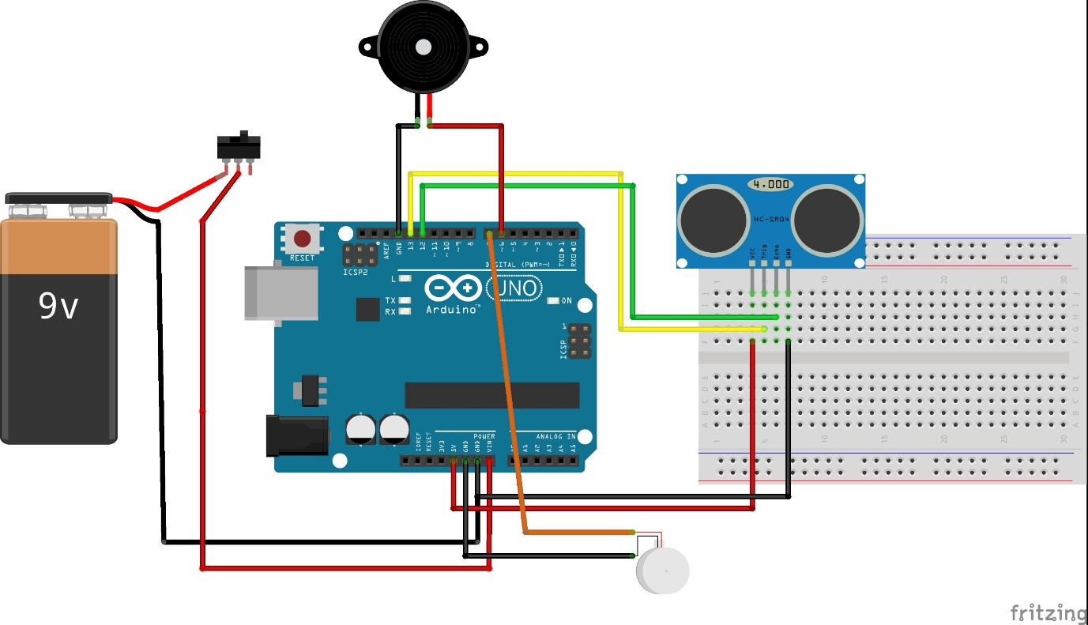

**PROJECT IMAGES:**

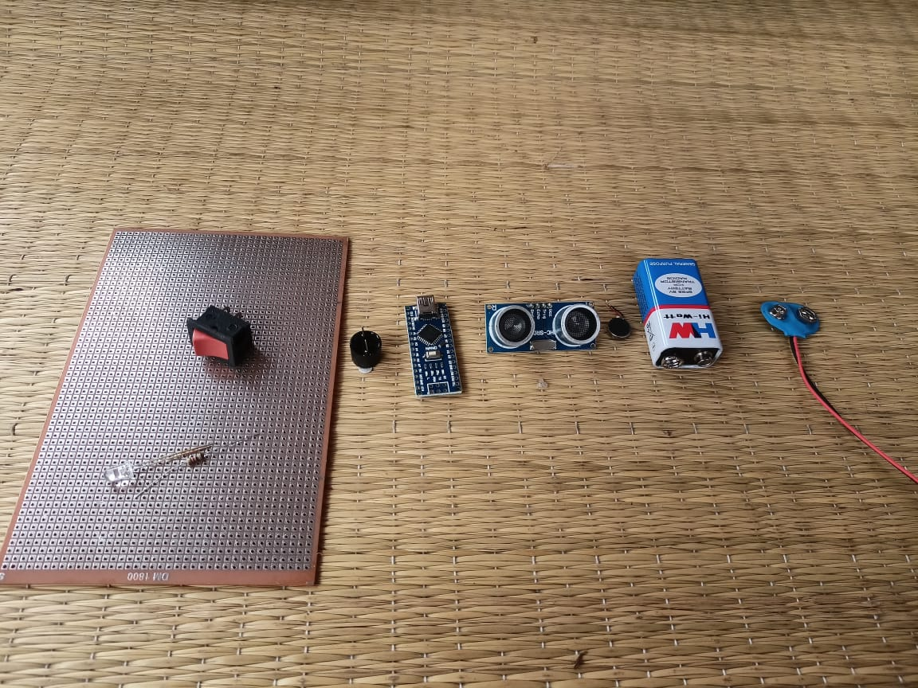

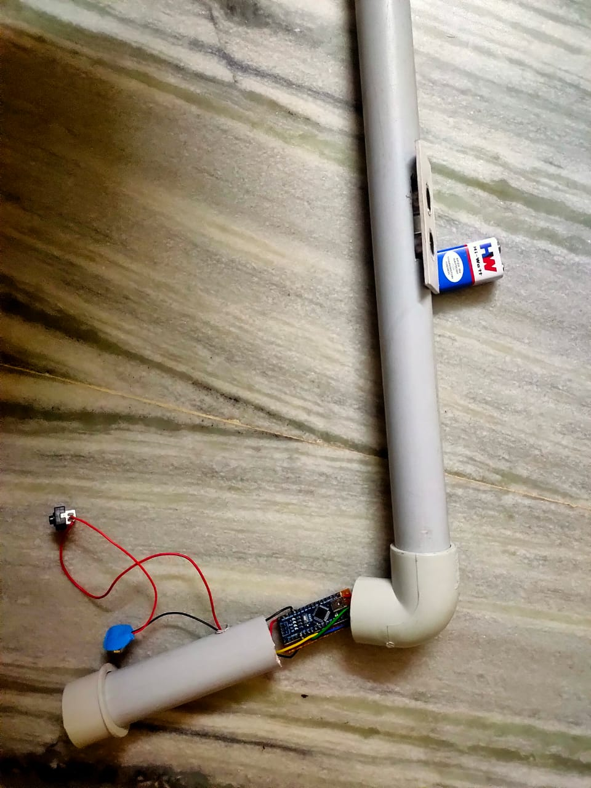

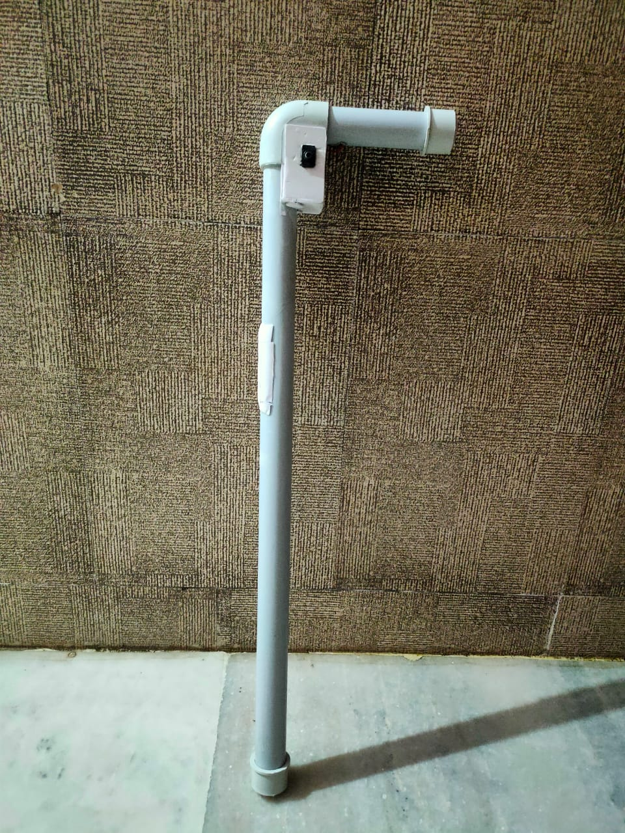

**RESULT:**

This project fills the limitations of a normal white cane stick used by a visually disabled person. It can help a blind person to walk and do their work independently with ease. By the warning given by this stick, the user gets to know about the obstacle on his path and even get to know the distance of it. Many features can also be added this stick to make it even more advantageous.